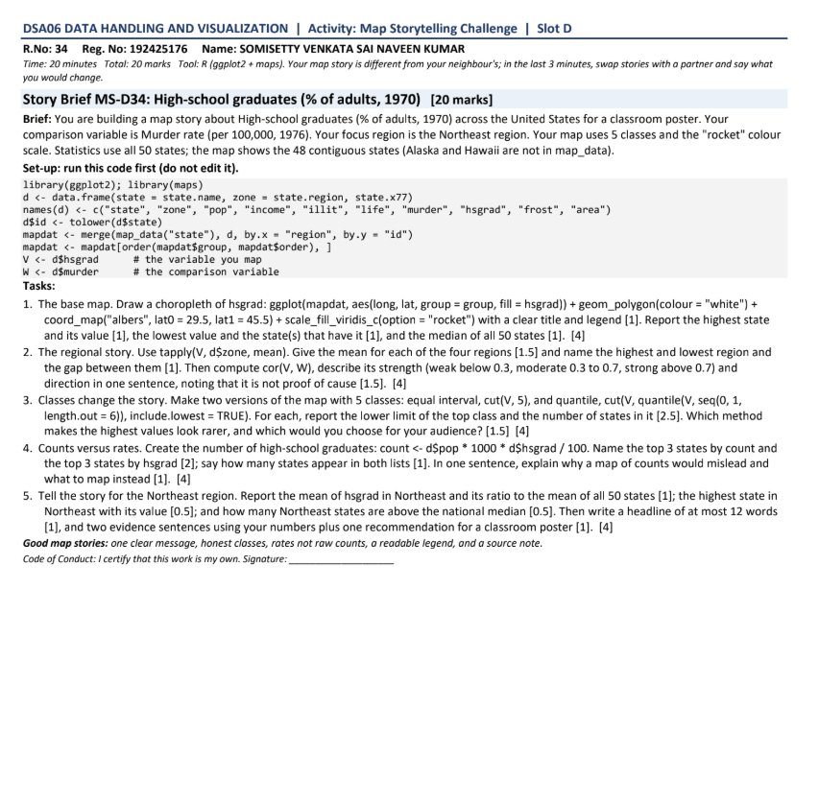
Story Brief MS-D34: High-school graduates (% of adults, 1970) – Comparison variable: Murder rate (1976) – Focus region: Northeast
Brief: You are building a map story about High-school graduates (% of adults, 1970) across the United States for a classroom poster. Your comparison variable is Murder rate (per 100,000, 1976). Your focus region is the Northeast region. Your map uses 5 classes and the "rocket" colour scale. Statistics use all 50 states; the map shows the 48 contiguous states (Alaska and Hawaii are not in map_data).
Set-up code (given):
library(ggplot2); library(maps)
d <- data.frame(state = state.name, zone = state.region, state.x77)
names(d) <- c("state", "zone", "pop", "income", "illit", "life", "murder", "hsgrad", "frost", "area")
d$id <- tolower(d$state)
mapdat <- merge(map_data("state"), d, by.x = "region", by.y = "id")
mapdat <- mapdat[order(mapdat$group, mapdat$order), ]
V <- d$hsgrad # the variable you map
W <- d$murder # the comparison variable

Task 1. The base map [4]
Question: The base map. Draw a choropleth of hsgrad: ggplot(mapdat, aes(long, lat, group = group, fill = hsgrad)) + geom_polygon(colour = "white") + coord_map("albers", lat0 = 29.5, lat1 = 45.5) + scale_fill_viridis_c(option = "rocket") with a clear title and legend [1]. Report the highest state and its value [1], the lowest value and the state(s) that have it [1], and the median of all 50 states [1]. [4]
Answer:
ggplot(mapdat, aes(long, lat, group = group,
fill = hsgrad)) +
geom_polygon(colour = "white") +
coord_map("albers", lat0 = 29.5, lat1 = 45.5) +
scale_fill_viridis_c(option = "rocket") +
labs(title = "High-school graduates by state, 1970",
fill = "% of adults",
caption = "Source: US Census Bureau, state.x77")
max(V); d$state[which.max(V)]
min(V); d$state[V == min(V)]
median(V)

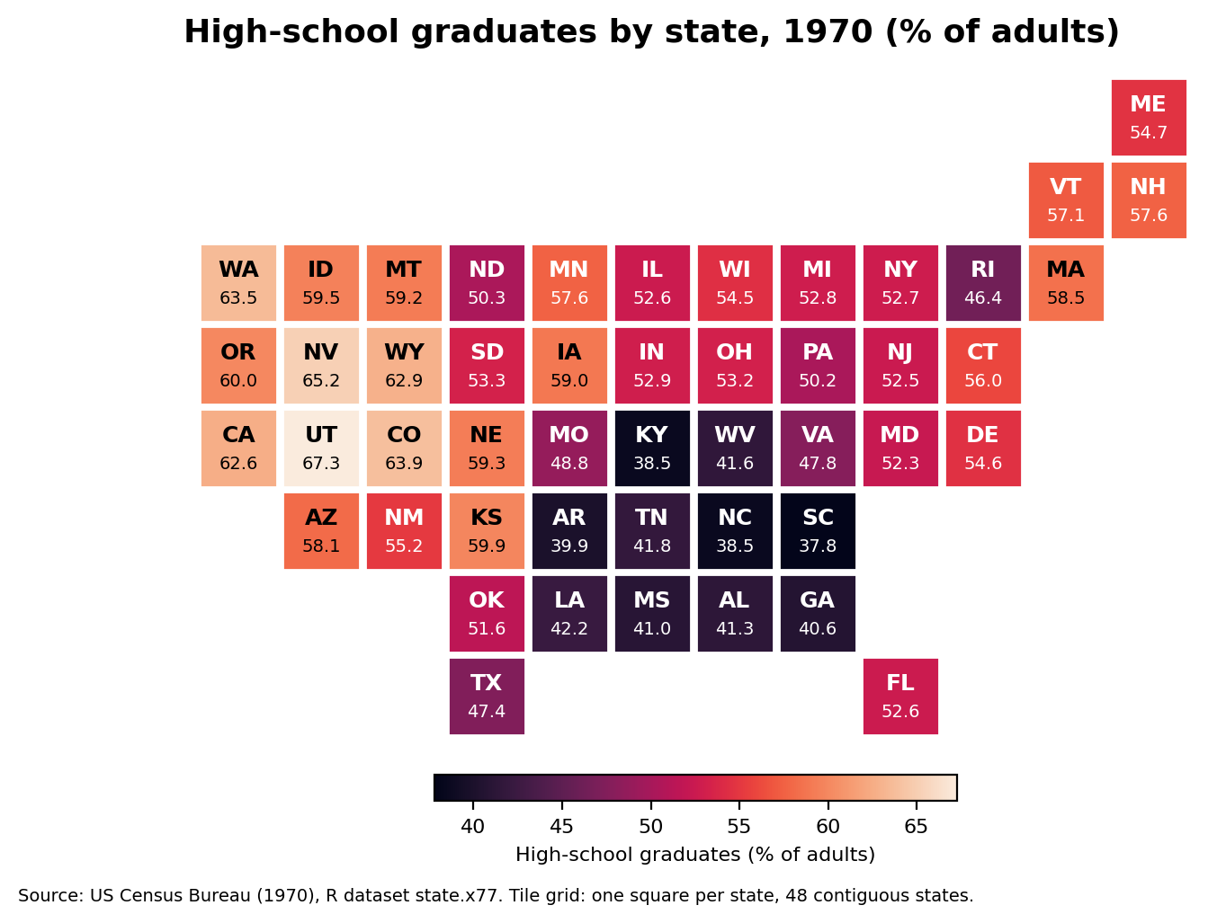
Figure 1. Choropleth of hsgrad (rocket scale), 48 contiguous states.
Highest state: Utah, with 67.3%.
Lowest value: 37.8%, held by South Carolina.
Median of all 50 states: 53.25%.
Task 2. The regional story [4]
Question: The regional story. Use tapply(V, d$zone, mean). Give the mean for each of the four regions [1.5] and name the highest and lowest region and the gap between them [1]. Then compute cor(V, W), describe its strength (weak below 0.3, moderate 0.3 to 0.7, strong above 0.7) and direction in one sentence, noting that it is not proof of cause [1.5]. [4]
Answer:
tapply(V, d$zone, mean)
cor(V, W)

Region | Mean hsgrad (%)
West | 62.00
North Central | 54.52
Northeast | 53.97
South | 44.34

The highest region is the West (62.00%) and the lowest is the South (44.34%), a gap of 17.66 percentage points.
cor(hsgrad, murder) = −0.49, which is a moderate, negative relationship: states with more high-school graduates tend to have lower murder rates. This is correlation, not proof of cause, because income, urbanisation and other factors may drive both.
Task 3. Classes change the story [4]
Question: Classes change the story. Make two versions of the map with 5 classes: equal interval, cut(V, 5), and quantile, cut(V, quantile(V, seq(0, 1, length.out = 6)), include.lowest = TRUE). For each, report the lower limit of the top class and the number of states in it [2.5]. Which method makes the highest values look rarer, and which would you choose for your audience? [1.5] [4]
Answer:
breaks_eq <- seq(min(V), max(V), length.out = 6)
mapdat$eq <- cut(mapdat$hsgrad, breaks_eq, include.lowest = TRUE)
mapdat$q <- cut(mapdat$hsgrad, quantile(V, seq(0, 1, length.out = 6)),
include.lowest = TRUE)
table(cut(V, 5))
table(cut(V, quantile(V, seq(0, 1, length.out = 6)), include.lowest = TRUE))
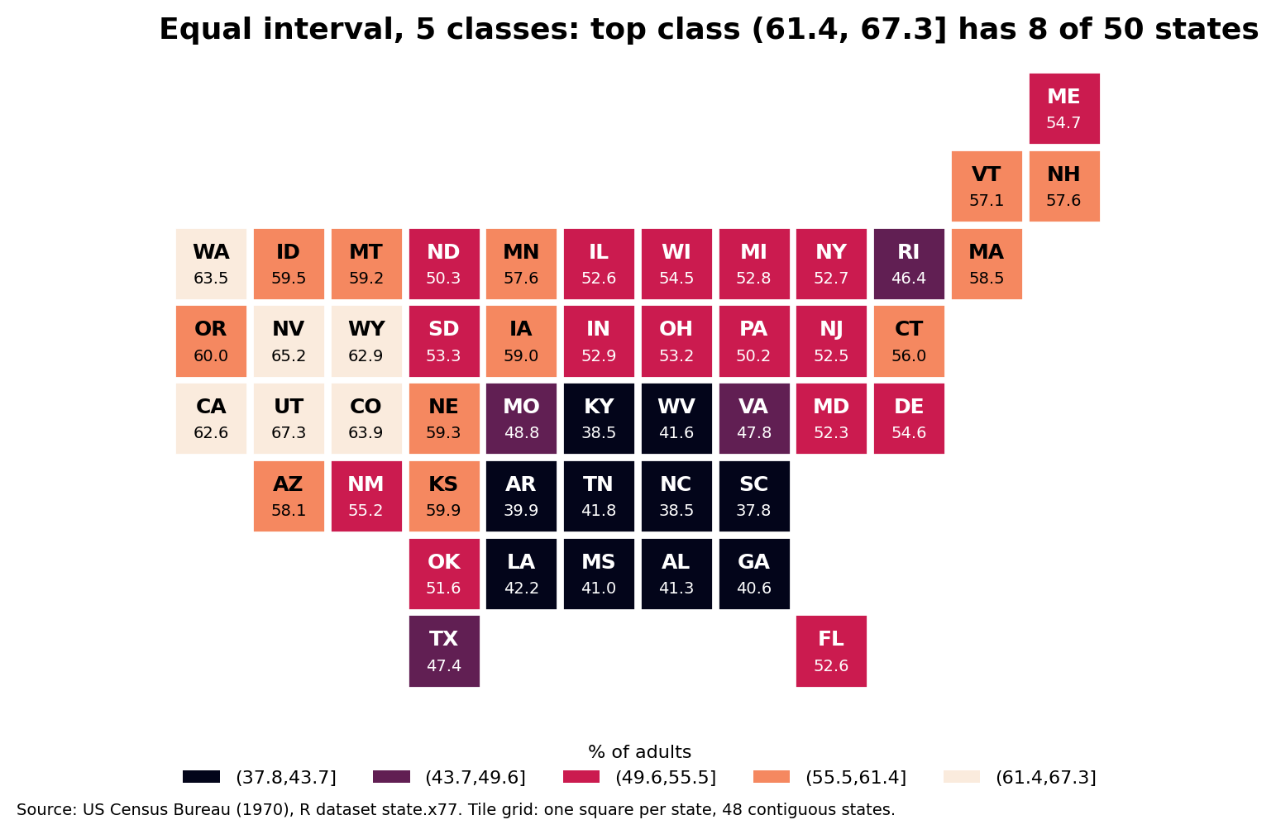
Figure 2. Equal interval classes, cut(V, 5).
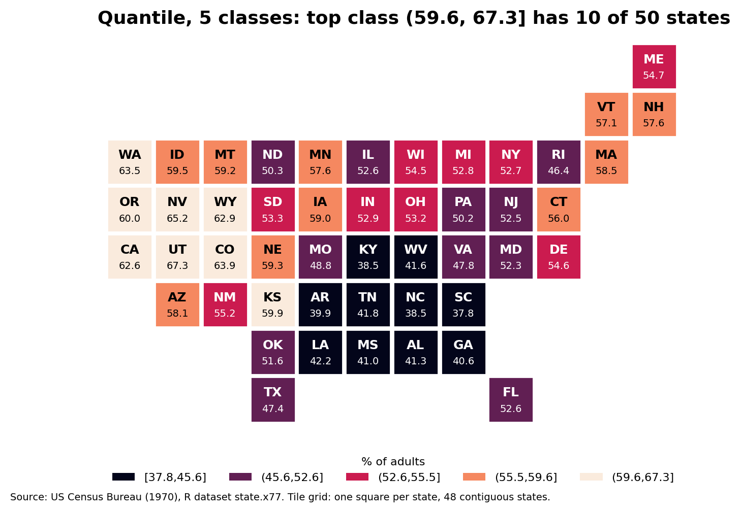
Figure 3. Quantile classes, 5 classes.
Method | Classes (count of states) | Top class lower limit | States in top class
Equal interval | 10, 4, 16, 12, 8 | 61.4% | 8
Quantile | 10, 11, 9, 10, 10 | 59.58% | 10

The equal interval method makes the high-graduation states look rarer: the top class has only 8 states (Utah, Alaska, Nevada, Colorado, Washington, California, Wyoming and Hawaii), and the second class has just 4, while 16 states are crowded into the middle class. Quantile classes put about 10 states in every class, so the map shows relative ranking evenly.
For a classroom poster I would choose quantile classes, because the audience wants to see which states rank high and low, and every colour then appears about equally often. I would print the class limits clearly in the legend, since quantile classes have uneven widths.
Task 4. Counts versus rates [4]
Question: Counts versus rates. Create the number of high-school graduates: count <- d$pop * 1000 * d$hsgrad / 100. Name the top 3 states by count and the top 3 states by hsgrad [2]; say how many states appear in both lists [1]. In one sentence, explain why a map of counts would mislead and what to map instead [1]. [4]
Answer:
count <- d$pop * 1000 * d$hsgrad / 100
Rank | By count (graduates) | By hsgrad (%)
1 | California (13,269,948) | Utah (67.3)
2 | New York (9,526,052) | Alaska (66.7)
3 | Pennsylvania (5,953,720) | Nevada (65.2)

States appearing in both top-3 lists: 0.
A map of counts would mislead because it mostly shows population size, so big states such as California and New York look best regardless of how well their adults actually did; we should map the rate (hsgrad, % of adults) instead.
Task 5. The Northeast story [4]
Question: Tell the story for the Northeast region. Report the mean of hsgrad in Northeast and its ratio to the mean of all 50 states [1]; the highest state in Northeast with its value [0.5]; and how many Northeast states are above the national median [0.5]. Then write a headline of at most 12 words [1], and two evidence sentences using your numbers plus one recommendation for a classroom poster [1]. [4]
Answer:
ne <- d$zone == "Northeast"
mean(V[ne]); mean(V[ne]) / mean(V)
d$state[ne][which.max(V[ne])]; max(V[ne])
sum(V[ne] > median(V))
Mean hsgrad in the Northeast: 53.97%, which is 1.02 times the mean of all 50 states (53.11%).
Highest Northeast state: Massachusetts, 58.5%.
Northeast states above the national median (53.25%): 5 of 9 (Connecticut, Maine, Massachusetts, New Hampshire and Vermont).
Headline: Northeast Tracks the National Average, With Rhode Island Lagging
Evidence: The Northeast mean of 53.97% is only about 1.02 times the national mean of 53.11%, and only 5 of its 9 states beat the national median of 53.25%. The spread is wide, from Massachusetts at 58.5% down to Rhode Island at 46.4%, a gap of 12.1 points.
Recommendation: For the classroom poster, map the hsgrad rate with 5 quantile classes, label the class limits in the legend, highlight the Northeast with an outline, and add the source note (US Census Bureau, 1970).
Source: US Census Bureau, 1970 data from R dataset state.x77; map data from the R maps package.

